MOOC 4-MODULE 3
Unsupervised Machine Learning

I.Hierarchical Agglomerative Clustering
Understanding Hierarchical Agglomerative Clustering
- The process begins by identifying the pair of points with the minimal distance, which is crucial for the algorithm's success.
- Distance metrics play a significant role in determining how clusters are formed, and the closest pairs can be either points or clusters.
Merging Clusters
- As the algorithm progresses, pairs of clusters or points are merged based on their proximity.
- The distance from a cluster to a point can be defined using various linkage criteria, such as the average distance of points in a cluster or the minimum distance between points.
Convergence and Stopping Criteria
- The algorithm continues merging until only one large cluster remains, which necessitates a stopping criterion to determine when to halt the merging process.
- This ensures that the clustering remains meaningful and does not result in a single cluster that loses the distinctiveness of the original data points.

II.Hierarchical Agglomerative Clustering: Hierarchical Linkage Types

Understanding Stopping Points
- The algorithm stops merging clusters when all average distances of clusters exceed a defined threshold (gray dotted line).
- Merging occurs iteratively, with clusters combined based on their average distances until all are above the threshold.
Linkage Types for Measuring Distances
- Single Linkage: Measures the minimum pairwise distance between clusters, ensuring clear separation but can be affected by outliers.
- Complete Linkage: Uses the maximum distance between points in clusters, better at handling noise but may break larger clusters.
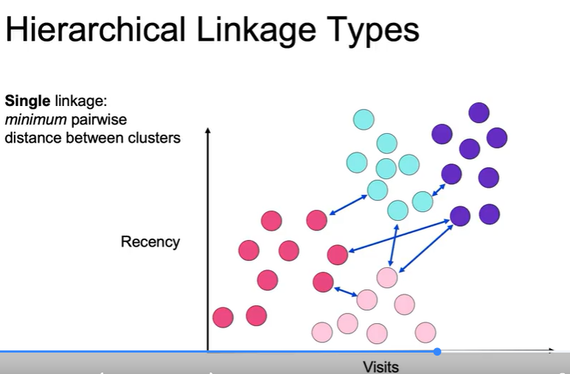
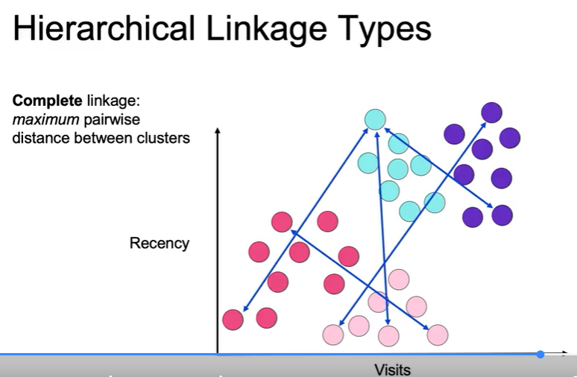
Average and Ward Linkage

- Average Linkage: Takes the average distance of points in clusters, balancing pros and cons of single and complete linkage.
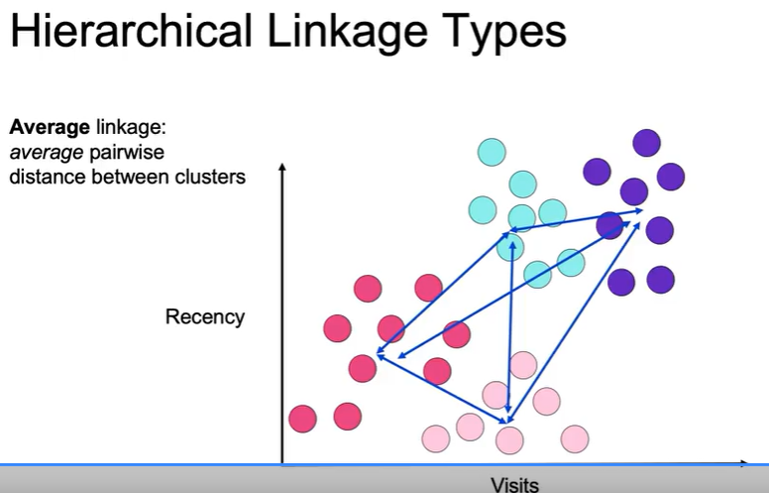
- Ward Linkage: Minimizes inertia (sum of squared distances to centroids), similar to k-means, aiming for optimal cluster formation.
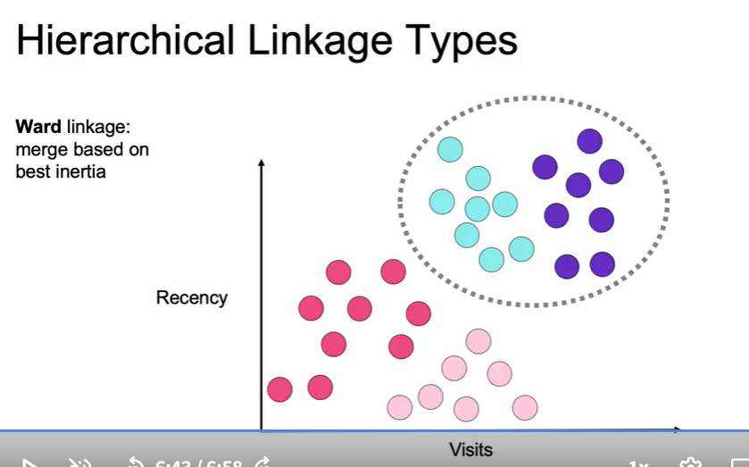

III.Applying Hierarchical Agglomerative Clustering
Hierarchical Agglomerative Clustering Overview
- The method involves importing the AgglomerativeClustering class and creating an instance with specified hyperparameters, such as the number of clusters.
- The distance metric, typically Euclidean, is chosen, and different linkage types can be defined for the clustering algorithm.
Key Concepts in Clustering
- The hierarchical agglomerative clustering method builds larger clusters from smaller subgroups, which is useful in business for identifying patterns.
- Stopping conditions can be predetermined, either by setting a specific number of clusters or by reaching a threshold of minimum average cluster distances.
Linkage Types
- Different linkage types include single linkage (using closest points), complete linkage (using furthest points), average linkage, and Ward's linkage (minimizing inertia).
- Each linkage type affects how distances between clusters are calculated, influencing the clustering outcome.
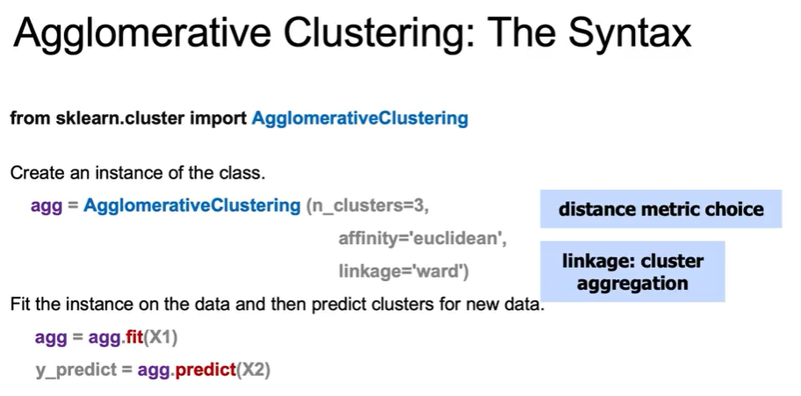

IV.DBSCAN
Understanding DBSCAN
- DBSCAN finds clusters by identifying points that are close to each other within a specified distance, rather than simply partitioning the data.
- The algorithm classifies points as core points, border points, or noise based on their density and proximity to other points.
Key Inputs for DBSCAN
- The distance metric is crucial for determining the similarity between points.
- Epsilon (ε) defines the maximum distance for points to be considered part of the same cluster.
- N_clu (minimum samples) specifies the minimum number of points required for a point to be classified as a core point.
Point Classification
- Core points have at least N_clu neighbors and are essential for forming clusters.
- Border points are reachable from core points but may not meet the core point criteria.
- Noise points do not belong to any cluster and lack nearby core points.

V.Visualizing DBSCAN
Understanding DBSCAN
- DBSCAN starts with a random point and defines a radius (epsilon) to identify neighboring points. If enough points are found within this radius, a cluster is formed.
- Points can be classified as core points (having enough neighbors), density-reachable points (near core points), or outliers (not part of any cluster).
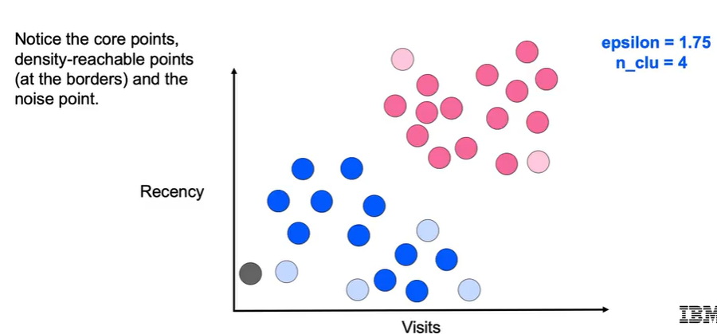
Strengths and Weaknesses of DBSCAN
- Strengths include automatic cluster determination, noise handling, and the ability to identify clusters of arbitrary shapes.
- Weaknesses involve the need for two parameters (epsilon and minimum samples), challenges in high-dimensional spaces, and difficulty with clusters of varying densities.
Implementation in Python
- The algorithm is implemented using the DBSCAN class from the Scikit-learn library, where parameters are set, and clusters are formed based on the defined epsilon and minimum samples. Outliers are labeled as -1.
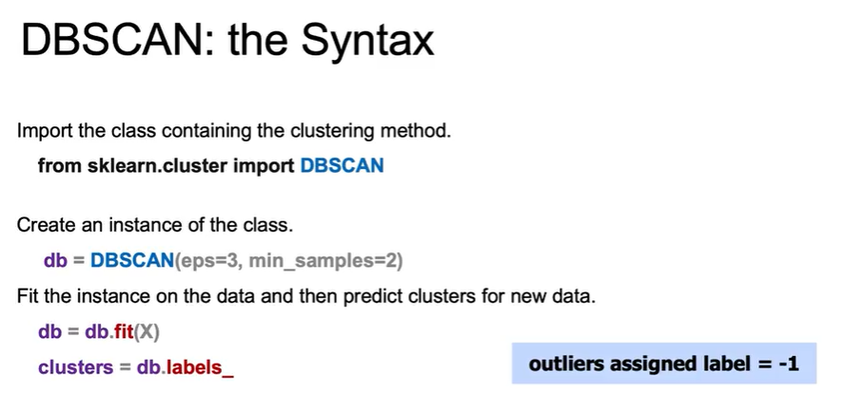

VI.Mean Shift
Mean Shift Clustering Algorithm
- The algorithm partitions points based on the densest point within a defined window, unlike k-means which uses the mean of points.
- It calculates a weighted mean around each point, giving more weight to points closer to the original point.
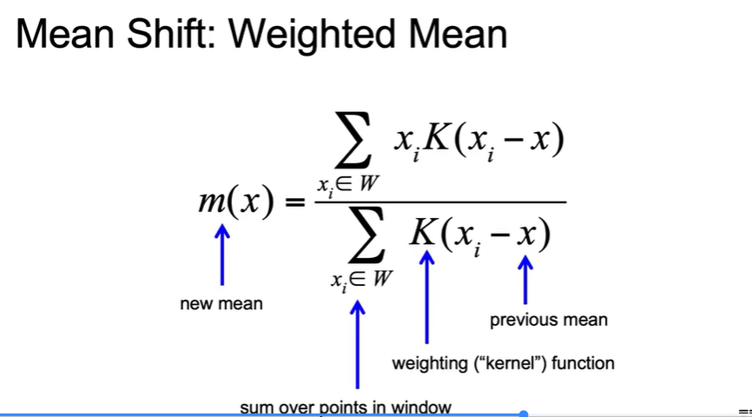
Steps to Implement Mean Shift
- Choose a starting point and window size, then calculate the weighted mean within that window.
- Shift the window to the new mean and repeat until convergence, grouping points that reach the same mode.
Strengths and Weaknesses
- Strengths: Model-free, does not require pre-defining the number of clusters, robust to outliers.
- Weaknesses: Results depend heavily on window size, and the algorithm can be slow with large datasets due to its complexity.

